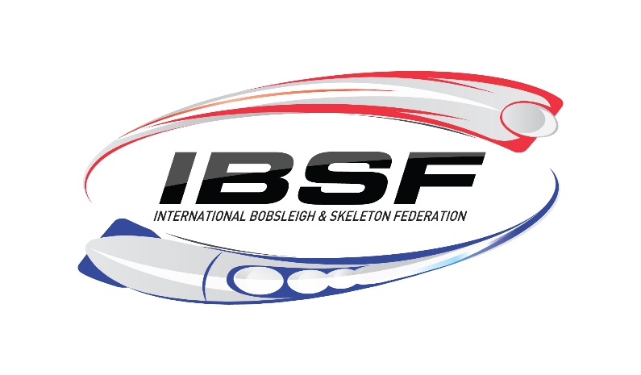

The Olympic Regional Development Authority and USA Bobsled & Skeleton
Invite all bobsled and skeleton member nations of the IBSF to compete in the
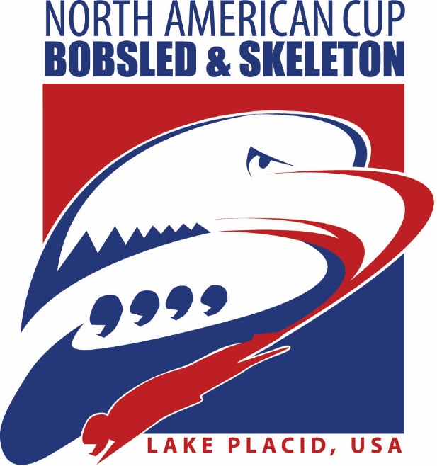

This event is hosted at the Lake Placid Sliding Center at Mount Van Hoevenberg
In accordance with the IBSF Rules.

Entry Deadline:
It is the National Federation’s responsibility to enter its athletes through the IBSF’s online system at http://ibsf.sportresult.com/Login.aspx. The deadline for submission is five (5) days before the first team captain’s meeting. NO EXCEPTIONS.

Matthew Yaniro, ORDA Events Manager
Phone: 518.523.1655 ext. 5331 Fax: 518.523.9275 Email: myaniro@orda.org

ORGANIZATION OF THE EVENTS
The competition is organized by the
Olympic Regional Development Authority (ORDA)
in conjunction with USA Bobsled & Skeleton

ORDA Board of Directors
Andy Lack, Vice Chairman
Basil Seggos, Commissioner NYS Department of Environmental Conservation
Erik Kulleseid, Commissioner NYS Department of Parks, Recreation & Historic Preservation
Howard Zemsky, Empire State Development Corporation
William Beaney
Jill Broderick
Clifford Donaldson, Jr.
John Parete
Arthur Lussi

Competition Committee
IBSF President Mr. Ivo Ferriani
NAC Coordinator Ms. Nicola Minichiello
Bobsled & Skeleton Race Director Mr. Zach Catillaz
Bobsled & Skeleton Asst. Race Director Mr. Eric Wilson
Bobsled & Skeleton Jury President Mr. Ken Delong
Bobsled Jury Member Mr. Tom Church
Skeleton Jury Member Mr. Ryan Schneider
Bobsled & Skeleton Material Controller TBD
Chief of Medical Dr. Eugene Byrne
IBSF Covid-19 Prevention Officer Manfred Maier
Venue Covid-19 Prevention officer Deb Pica

Organizing Committee

Chairman Mr. Jeff Potter
USABS Executive Director Mr. Aron McGuire
Venue Manager–Mount Van Hoevenberg Ms. Rebecca Dayton
Event Manager Ms. Jenna Lute
Event Manager Mr. Matthew Yaniro
Event Logistic Coordinator Mr. Nick Zachara
Timing and Scoring Mr. Zach Catillaz
Marketing/Promotion Mrs. Jennifer McKeever
Media Information—ORDA Mrs. Elise Ruocco
Media Information— USABS Mrs. Amanda Bird
Technology Mr. Phil Baumbach

INVITATION TO COMPETE
The United States Bobsled and Skeleton Federation and the Olympic Regional Development Authority invite all national federations affiliated with the IBSF to compete in the 2021 IBSF North American Cup Tour in the following disciplines:
2-Man Bobsled
4-Man Bobsled
2-Woman Bobsled
Women’s Monobob (Part of Women’s Monobob World Series)
Men’s Skeleton
Women’s Skeleton

Medals awarded to the top three finishers in each race. Timing scored to 1/100th of a second.

REGISTRATION DEADLINE: It is the National Federation’s responsibility to enter its athletes through the IBSF’s online system at http://ibsf.sportresult.com/Login.aspx. The deadline for submission is five (5) days before the first team captain’s meeting. This must include all NF athletes and staff members. There will be no exceptions if you miss the deadline.

LIABILITY
All athletes, officials and other members of the national association who attend and participate in this event do so at their own risk. The Organizing Committee shall not be responsible for any loss or injuries incurred or suffered by any athlete or official in conjunction with the organization or staging of the event. All athletes will be required to sign a waiver prior to sliding.

ENTRY FEES
All race entry fees will be paid electronically; exact details of how to pay will be communicated prior to the event.
Men’s Bobsled €20 per athlete per race ($25.00 USD)
Women’s Bobsled €20 per athlete per race ($25.00 USD)
Skeleton €25 per athlete per race ($31.00 USD)

HOUSING
Expenses and reservations for housing and transportation are the responsibility of each team/federation. A wide range of local accommodations can be found HERE

OPTC Housing:

Due to the global pandemic, the OPTC is not hosting international athletes for the foreseeable future. At this time they are able to accommodate Team USA Athletes who are Beijing and Tokyo bound only.

SLED STORAGE
Limited bobsled storage is available. Advance reservation is required. Reservations may be made by contacting Zach Catillaz at (518)-534-2937 or osctiming@orda.org
Lake Placid Sliding Center Address:
Lake Placid Sliding Center at Mt. Van Hoevenberg
220 Bobsled Lane, Lake Placid, NY 12946 USA
Tel. (518) 523-4436

RACE OFFICE
The race office will be located at the Finish Building at the Lake Placid Sliding Center.

MEETING LOCATIONS
All Team Meetings are remote. Login details will be communicated on the meeting date directly to Team Captains and Hygiene Officers by Nicola Minichiello (NAC Coordinator)

National Interest Exemption Waiver:
In order to prevent the spread of COVID-19 the US Government is restricting entry into the United States of America by foreign nationals, regardless of citizenship, who have had a physical presence in a restricted nation at any point in the 14 days before their arrival. Foreign nationals (excluding legal permanent residents) may not enter without receiving a National Interest Exemption 212(f) waiver from the Department of Homeland Security.
The following countries are restricted: Asia/Middle East: China and Iran Europe: Austria, Belgium, Czech Republic, Denmark, Estonia, Finland, France, Germany, Greece, Hungary, Iceland, Ireland, Italy, Latvia, Liechtenstein, Lithuania, Luxembourg, Malta, Netherlands, Norway, Poland, Portugal, Slovakia, Slovenia, Spain, Sweden, Switzerland, and the U.K. South America: Brazil
For an up to date list of restricted countries please visit this link.
Note: Transit through any of the listed nations (ex: flight lay-over) constitutes as having a physical presence.
U.S. Olympic & Paralympic Committee National Interest Exemption for Events and Training:
On August 11, 2020, DHS issued a National Interest Exemption notice to the USOPC for international athletes, essential staff, and their dependents participating in senior-level international competitions and training. The Government Relations office is facilitating the waivers through U.S. Customs and Border Protection.
Instructions for NGBs:
- Complete the waiver request spreadsheet (included) for each traveler(s) at least seven (7) days prior to the expected arrival to the United States. Note: if the traveler(s) needs to secure a visa in addition to a travel waiver, submit the waiver request at the same time as the visa application. Send the completed request myaniro@orda.org.
- Within 72 hours of submission, the USOPC will notify the NGB of the waiver status. When clearance is granted, the USOPC will provide a confirmation letter as evidence of a 212(f) waiver. 3.
- Advise the traveler(s) to check the information on the U.S. Embassy website in the country where they reside. Each embassy may have specific instructions for individuals to travel on a National Interest Exemption. If asked, the traveler(s) should provide the USOPC waiver confirmation letter.
Additional Information:
The waiver, if granted, does not exempt travelers from inspection by U.S. Customs and Border Protection or exempt them from standard entry requirements, including visa, passport, and any other necessary documentation requirements.
Waivers are valid for multiple entries as long as the purpose of the trip is pertinent to the NGB/event organizer. Waivers are valid for 1 year.
CBP recommends limiting the amount of travel and following CDC guidelines to minimize exposure.

Covid-19 Prevention Information:

IBSF Covid-19 Coordinator: Nicola Minichiello / Nicola.minichiello@ibsf.org

Race Organizer Covid-19 Coordinator: Deb Pica / dpica@orda.org

New York State Mandatory Pre-Arrival Testing

All travelers from a noncontiguous state, US territory or CDC level 2 and higher country wishing to test out of the mandatory 10-day quarantine complete the following steps:

Obtain a Covid test (any form) within 72 hours (3 days) of departure and prior to arriving in New York State.

A copy of your test result must also be emailed to dpica@orda.org prior to arrival.

Upon arrival to New York the traveler must quarantine for a period of 72 hours (3 days).

On the fourth day of quarantine, the traveler must obtain second Covid test.

If both tests come back negative, the traveler may exit the 10-day quarantine early upon receipt of the second negative test.

Please refer to the Mt. Van Hoevenberg Covid-19 Guidelines for further information on pre-arrival testing.

Covid-19 Event Testing Schedule in Lake Placid:

Date Time Location
Thursday, January 28th- Bobsled 18:00
Monday, February 1st- Bobsled 18:00 Olympic Jumping Complex Base Lodge- 1st Floor
Monday, February 1st- Skeleton 19:00

All IBSF, New York State and Event/Venue Covid Protocols are available on our North American Cup Bobsled & Skeleton website: WIP

During this pandemic we all must be vigilant. Being socially distant whenever possible, wearing face coverings always and following proper hygiene recommendations will contribute to the success of the North American Cup. The better we follow these guidelines the less chance for one positive result to affect the entire competition.

EVENT SCHEDULE
As of January 15th, 2021 - (Subject to Change)

Monday, January 25
Bobsled Arrival & 72 Hour Quarantine All Day Lodging Quarters

Tuesday, January 26
Bobsled 72 Hour Quarantine All Day Lodging Quarters

Wednesday, January 27
Bobsled 72 Hour Quarantine All Day Lodging Quarters

Thursday, January 28
TCM- Bobsled 13:00 (Approx.) Remote via Zoom
Covid Testing- Bobsled 18:00 OJC Intervales Lodge

Friday, January 29
Skeleton Arrival & 72 Hour Quarantine All Day Lodging Quarters
Track Walk 09:00-10:00 LPSC
Bobsled Official Training – 3 Runs 10:00-12:00 LPSC

Saturday, January 30
Skeleton 72 Hour Quarantine All Day Lodging Quarters
Track Walk 09:00-10:00 LPSC
Bobsled Official Training – 3 Runs 10:00-12:00 LPSC

Sunday, January 31
Skeleton 72 Hour Quarantine All Day Lodging Quarters
Track Walk 09:00-10:00 LPSC
Bobsled Official Training – 2 Runs 10:00-12:00 LPSC
TCM/Draw- Bobsled 14:00 Remote via Zoom

Monday, February 1
2-Man Bobsled Race #4 | Women’s Mono Race #4 10:00-12:00 LPSC
Skeleton TCM 15:00 (Approx.) Remote via Zoom
Bobsled Covid Testing 18:00 OJC Intervales Lodge
Skeleton Covid Testing 19:00 OJC Intervales Lodge

Tuesday, February 2
Track Walk 08:00-09:00 LPSC
Skeleton Official Training – 3 Runs 09:00-12:00 LPSC
2-Man Bobsled Race #5 | Women’s Mono Race #5 13:30-15:30 LPSC
Awards: 2-Man and Women’s Mono Immediately After Race Finish Deck

Wednesday, February 3
Track Walk 08:00-09:00 LPSC
Skeleton Official Training – 3 Runs 09:00-12:00 LPSC
4-Man & 2-Woman Bobsled Race #4 13:30-15:30 LPSC
Skeleton TCM/Draw 14:00 Remote via Zoom

Thursday, February 4
Men’s & Women’s Skeleton Race #4 09:00-12:00 LPSC
4-Man & 2-Woman’s Bobsled Race #5 13:30-15:30 LPSC
Awards: 4-Man & 2-Woman Immediately After Race Finish Deck

Friday, February 5
Men’s & Women’s Skeleton Race #5 09:00-12:00 LPSC
Awards: Men’s & Women’s Skeleton Immediately After Race Finish Deck

